Pre-referral checklist
The housing related support (HRS) panel has compiled the following checklist to help referrers decide if they wish to complete the referral form, both in terms of their client’s eligibility and to check that suitable provision for their needs exists within HRS.
Clients can only be considered by the HRS panel if they meet the following criteria:
- They are 18+, single, with no dependent children

- They are normally resident in the Kent local authority area

- They have a mental health diagnosis confirmed by supporting documentation from a relevant professional. This documentation must be sent in at the same time as the referral form. (Clients without a confirmed mental health diagnosis are not eligible for HRS and their referral will not be processed)

- Their primary need is mental health

- They are committed to following a recovery-focused support plan for their mental health and working with staff towards a more independent living situation within two years

- They are not in an acute or crisis state of mental ill-health at the time of their application to HRS

- If they have a history of substance use, they will need to demonstrate that they are actively managing this prior to applying to HRS

- They do not present a significant risk to others due to their offending history

- The client has a local connection to the area they are interested in (appendix 2 shows the location of all the HRS schemes) unless:

- exemptions to the need for a local connection apply or
- another local authority has committed in writing to rehouse them at the end of their stay in HRS accommodation
Please contact us for advice on this if needed, before completing the referral form.

- Most HRS schemes offer low or low/medium levels of support – if you consider your client has higher levels of support need than this, please contact us first to see if there are any suitable schemes in the area, they are interested in. (They may be able to apply for lower support schemes if they are able to access a top-up package of support that works alongside, but does not duplicate, the HRS service).

- Most HRS schemes do not accept pets – please contact us first to see if there are any schemes in the area the client is interested that will consider pets

- If their mental health needs can reasonably be met by a community-based service in their current accommodation, they will not be considered for HRS supported housing


Mental health housing related support service
Referral form
This form should be completed by the referring professional with the referred person, as we do not take self-referrals for this service.

Scope of the mental health housing related support (HRS) service:
- To improve people’s mental health recovery, preparing them to move on to live more independently and/or with reduced support.
- To provide time-limited support of up to two years, focused on moving on to greater independence.

- For further information on eligibility criteria and how the service works see appendix 1.
- For information on the location of HRS schemes see appendix 2.
- This application for housing does not comprise an offer or part of an offer of accommodation and does not bind HRS providers in any way.
- If any forensic assessment/history exists, it must be declared, and a copy of documentation attached.
- Please complete all sections as fully as possible as insufficient detail will delay the referral process.

Consent
The referrer must obtain the following three types of consent from the applicant prior to completing this form. Referrals without these consents will not be considered. The referrer may sign /print consent on the applicant’s behalf with their prior permission, which must be confirmed by covering email or indicated in the box below.
I give my consent for this referral to be made to HRS on my behalf.
I give my consent for information relating to my application to be shared with the Live Well Kent and Medway HRS mental health panel and any contracted Live Well Kent and Medway HRS mental health providers and scheme that may be thought appropriate.
I give my consent for information relating to my application to be treated in line with Live Well Kent and Medway data protection obligations.
Signed by applicant:
Print applicant’s name:
Date

Client opting in or out?
Does the applicant wish to be kept informed by us at key stages of this referral process? (If no, they will only be kept informed by you as the referrer. If yes, they will need to supply an email address below). | Yes |  | No

Referral documentation
To enable us to process the application promptly, please ensure that all documentation attached in support of this application is attached and is up to date. Failure to provide this information will delay the application. Please indicate which documentation you have supplied:

Clinical risk assessment attached | Yes |  | No
Forensic history attached | Yes |  | No
Do they have a current CPA? If yes, please attach as the referral cannot be processed without it | Yes |  | No

Client details
Name
Pronouns (they/them, she/her, he/him etc.)
Date of birth
Address (including postcode) where you are currently living
Usual address (including postcode) if different from the above
Telephone number
Email address
NI number |  | NHS number
Next of kin or significant other:
1. Name
Contact number
Email address
2. Name
Contact number
Email address
Gender:
Male |  | Female |  | Non-binary
Other (please complete): |  |  |  | Does not wish to disclose
Does your gender correspond with the sex you were assigned at birth?
Yes (i.e. cisgender) |  | No (i.e. transgender, non-binary or other gender identity) |  | Does not wish to disclose

Are you intersex? (i.e. were you born with a variation in your physical sex characteristics?)
Yes |  | No |  | Does not wish to disclose
Ethnicity:
Asian/Asian British: Bangladeshi |  | Mixed: white & Asian
Asian/Asian British: Indian |  | Mixed: white & Black African
Asian/Asian British: Pakistani |  | Mixed: white & Black Caribbean
Asian/Asian British: other |  | Mixed: other
Black/Black British: African |  | White: British
Black/Black British: Caribbean |  | White: Irish
Black/Black British: other |  | White: other
Chinese/Chinese British |  | Other:
Gypsy/Irish traveller |  | Does not wish to disclose
Religion:
Buddhist |  | Christian |  |  | Hindu
Jewish |  | Muslim |  |  | Sikh
None |  | Other: |  |  | Does not wish to disclose
Sexuality:
Bisexual |  | Gay/Lesbian |  |  | Heterosexual
Questioning |  | Other: |  |  | Does not wish to disclose
Relationship status:
Single |  | Married |  | Civil partnership
Divorced |  | Widowed |  | Cohabiting
Does not wish to disclose
Do you have a dependent child (under the age of 18) that lives with you?
Yes |  | No |  | Does not wish to disclose
Are you ex-armed forces?
Yes |  | No |  | Does not wish to disclose
Economic status:
Full-time student |  | Full-time work >24hrs/wk |  | Part-time work <24hrs/wk
Jobseeker |  | DWP employability programme |  | Not seeking work
Other adult |  | Long-term sick/disabled |  | Retired
Does not wish to disclose
Are you a carer? (Do you look after, or give any help/support to family members, friends, neighbours or others because of either: long-term physical or mental ill-health; or problems related to old age?)
Yes |  | No |  | Does not wish to disclose

If you are a carer, are you in receipt of carer’s allowance?
Yes |  | No |  | Does not wish to disclose
Are you a care leaver?
Yes |  | No |  | Does not wish to disclose
If yes, within which local authority were you cared for?
Do you have a disability (as defined by the Equality Act 2010)?
Yes |  | No |  | Does not wish to disclose
If you have a disability, how can this best be described?
Physical/mobility impairment |  | Sensory
Mental health condition |  | Learning difficulty/disability
Long-standing illness or health condition (e.g. cancer, HIV, diabetes) |  | Other:
If you have a disability, are you in receipt of DLA/PIP/attendance allowance?
Yes |  | No |  | Does not wish to disclose
About this referral
Referrer details
Name
Email address
Date |  | Contact number
Job title
Organisation
How long have you known the person you are referring? |  |  |  | years |  | months
When was the last time you had contact with the person you are referring?
Was this contact face-to-face or by phone?
Has the scope of the service been discussed with the applicant, so they are aware it is a time-limited service focused on mental health recovery and preparing to move on to independent living? |  |  | Yes |  | No
Does the client know and accept that they will need to engage with support while in the HRS service, such as taking part in regular key-working and committing to working on a support plan? |  |  | Yes |  | No
Reason for referral
Primary mental health diagnosis from a professional (please attach supporting documentation – referrals cannot be processed without this)

Which kind of professional made or confirms this mental health diagnosis?

Summary of mental health and psychiatric history:

Please list other diagnoses and who made them:
Current living situation:

Background information/social history (e.g. family support, local connections, bereavement, education, and employment history):

Medication
Name of medication | Dosage | What are you taking the medication for? | How long have you been taking it? | Any issues/ side effects with taking this medication? | Are you able to manage your own medication?
Housing history for the last five years
From | To | Type of accommodation (please include whether  shared or self-contained and tenure e.g. private rented/owner occupier/social housing or if NFA) | Name of provider  (if applicable) | Town and local authority area (including if NFA) | Reason for leaving, including reason for any evictions
Local connection
To which of the following districts boroughs does the person have a recognised local connection*?
(*local connection generally refers to having lived in an area for at least 2 out of the last 5 years or having family members they are in regular contact with in that area. Please note that most HRS offers of accommodation are based on local connection and that different local authorities have different criteria for how they assess local connection)
Please tick all the local connections that apply:
Dartford |  |  |  | Maidstone
Gravesham |  |  |  | Thanet
Dover |  |  |  | Folkestone & Hythe
Sevenoaks |  |  |  | Canterbury
Swale |  |  |  | Tunbridge Wells
Tonbridge & Malling |  |  |  | Ashford
Subject to establishing a local connection with the local authority, where needed, which of the above areas would the person prefer to live in? Please give supporting reasons:

Does the applicant wish to be housed by a particular HRS provider? If so, please give reasons. (Please note that this cannot be guaranteed as the panel has to consider a range of factors in its referral decisions).
Are there any areas the person would not consider moving to/cannot move to, e.g. due to exclusions or safeguarding reasons, such as domestic abuse? Please explain their reasons:

Type of accommodation the person will consider (please tick all that apply):
Self-contained | Yes |  |  | No |  |  | Maybe
Their own room, but with shared facilities | Yes |  |  | No |  |  | Maybe
Does the person have any pets?  (There are very few HRS schemes that allow pets, so they may need to consider rehoming their pet if accepted by HRS) |  |  |  |  | Yes |  |  | No
If yes, please detail:

Does the person have any physical disability, accessibility and/or additional needs to be considered in any offer of accommodation, such as floor level? If yes, please give details.

Please describe any physical or other adaptations which may be required to enable the person to use or access this service (including any reasonable adjustments under the Disability Discrimination Act 1995)

Support needs
Area of need | Please give brief details of support required:
Living skills:
Taking care of a home, keeping it clean and tidy, dealing with money, paying bills, help with benefit claims, getting out and about and managing shopping and cooking.
Managing mental health:

Feels completely overwhelmed by these or has a good understanding of what is happening versus being able to cope in a positive way with difficult experiences, feelings, or thoughts.
(Note that this is not about being free of mental health issues but knowing what to do if/when they arise.)
Self-care/physical health:

Taking care of them-self, e.g. keeping fit physically, taking care of appearance and being aware of personal safety
Social networks:

Interaction with others and engaging in social activities, whether this is family or friends or through groups or activities.
Relationships:

This is about having meaningful relationships i.e. a close friend/ a partner/ a parent or a sibling. Do they have someone that they feel they can trust and can share personal issues with? Are they able to distinguish between healthy and unhealthy relationships?

Work and education:

This is about taking part in work-related activities that contribute to wider society i.e. paid work, training/education, or voluntary work
Identity and self-esteem:

How do they feel about themselves; do they have a good sense of who they are and what they are about?
We’re also considering here how confident they feel when in social situations.
Addictive behaviour:

This is about the role of addiction in their life. Do they use drugs or alcohol to cope with difficulties? Do they feel dependent on things such as gambling, food or exercise?
To what extent is this an issue for them or people close to them?
Trust and hope:
How do they see the future – do they have positive expectations of what they can do with their life?
Responsibilities:

This is about dealing with different responsibilities, respecting others, and recognising boundaries. Do they consider how their actions and behaviour can impact on others?
Other support:

Please outline any other form of support they would need to maintain their tenancy and work towards independent living in the community.

What level of support do they require from HRS? Please tick one.  Please note that most HRS schemes offer low or low/medium support.  Where a top-up care package is available that might enable the applicant to access the HRS service, please mention this here. Please note: top-up packages must only meet social care needs and must not duplicate any aspect of the mental health housing related support service offered by HRS. | Low (up to 5 hours of support per week) | Medium (6-10 hours support per week) | High (11-15 hours per week)
Personal statement (for the applicant to complete in their own words, with referrer support as needed)
What difference would living in one of the HRS schemes make to your mental health recovery and independence?
How does your mental health impact you on a day-to-day basis?
How is your current housing situation affecting your mental health recovery journey?
Support network
GP details
GP name
Surgery name
Contact number
Mental health services currently engaged
Service name |  | Date started
Service name |  | Date started
Attendance at acute or crisis service in the last 12 months? Please give details.
Consultant psychiatrist (or mental health professional responsible for care)
Name of professional
Name of mental health unit
Contact number
Email address
Social worker
Name
Contact number
Email address
Community psychiatric nurse (CPN)
Name
Contact number
Email address
Probation officer
Name
Contact number
Email address

Finances
Please detail all sources of income and any debts to assist with assessing ability to afford the charges for the HRS service.
Type of benefit / other income source | Weekly / monthly amount
Debt / money owed | Weekly / monthly payment schedule
Any benefit sanctions? | Details

Safeguarding and risk
Safety of self | Y (yes)  N (no) | Present (P)  Historical * (H)  Never (N) | Likelihood  Low, medium, or high | Severity  low, medium, or high | Please give details below.  *If historical please indicate if: 3-6, 6-9, 9-12, 12-18 or 18-24 months ago
Has anyone ever exploited them financially? (e.g. lack of control of own finances, other people taking their money)
Has anyone ever emotionally/sexually exploited them in anyway? (e.g. excessive criticism, emotional neglect or control, sexual abuse, prostitution)
Has anyone physically harmed them in any way on a regular basis?
(e.g. violence or coercive behaviour by others, confinement)
Do they believe they have ever NOT taken care of themselves for a prolonged period? Hygiene/diet/
exercise (e.g. over/ underweight, personal hygiene, excessive or inadequate exercise, poor diet)
Do they have any difficult with memory? (e.g. with sequencing events such as dressing, cooking, or shopping)
Have they ever self-harmed before? (e.g. through cutting, overdose, physically causing pain to self)
Have they ever attempted suicide or experienced suicidal ideation?
Have they ever been on the Child Protection Register?
Have they been subject to MAPPA, MARAC or safeguarding?
Safety of others | Y (yes)  N (no) | P (present  *H (historical)  N (never) | Likelihood:  Low, medium, or high | Severity:  Low, medium, or high | Please give details below.  *If historical please indicate if: 3-6, 6-9, 9-12, 12-18 or 18-24 months ago
Have they ever been involved with the police or committed an offence? (e.g. ASBOs, court orders, cautions, convictions)
Have they ever committed arson?
Are they on the Sex Offenders Register?
Do they believe they can be verbally or emotionally hostile towards others? (e.g. abusive language, excessive criticism, shouting, manipulation)
Do they believe they can be physically hostile towards others? (e.g. violence, harassment)
Have they ever exploited or harmed someone else? (e.g. sexual, emotional, physical, emotional)
Have they ever purposely damaged property? (e.g. arson, graffiti, breaking building or furniture, other non-police involvement)
Mental health – do they experience any of the following? | Y (yes)  N (no) | P (present  *H (historical)  N (never) | Likelihood:  Low, medium, or high | Severity:  Low, medium, or high | Please give details below.  *If historical please indicate if: 3-6, 6-9, 9-12, 12-18 or 18-24 months ago
Depression (e.g. low mood, lethargy, sleep disturbance, slowed movements)
Anxiety (e.g. OCD, agoraphobia, panic attacks)
Hallucinations (e.g. unusual auditory/ visual/tactile/ olfactory perceptions)
Paranoia/delusions (e.g. fear of others trying to harm you, disjointed view of the world)
Mood swings (e.g. anger, mania with labile mood, unpredictable manner, bipolar disorder)
Substance use | Y (yes)  N (no) | P (present  *H (historical)  N (never) | Likelihood:  Low, medium, or high | Severity:  Low, medium, or high | Please give details below.  *If historical please indicate if: 3-6, 6-9, 9-12, 12-18 or 18-24 months ago
Do they/have they misuse/d alcohol or drugs?
(List type in details column e.g. beer/spirits/cannabis/ crack cocaine/heroin/ khat/amphetamines etc.)
Any other information
Please provide details below of any other significant issues, especially if they relate to health and safety, that we should be aware of that have not already been disclosed and might affect this application.
Statement by referrer
I declare that that all relevant information has been included in the above statements and that all relevant and current documentation is attached in support of this application.
Signed by referrer
Print referrer’s name:
Date
To make your referral, please send by secure email to one of the following:For services in West Kent (including Sevenoaks, Tonbridge & Malling, Tunbridge Wells and Maidstone), Canterbury & Coastal and Ashford, please contact livewellkentreferrals@shaw-trust.org.uk
For services in Thanet, South Kent Coast, Swale and Dartford, Gravesham & Swanley, please contact livewellkentHRS@porchlight.org.uk

Appendix 1 – HRS eligibility criteria and how the service works:
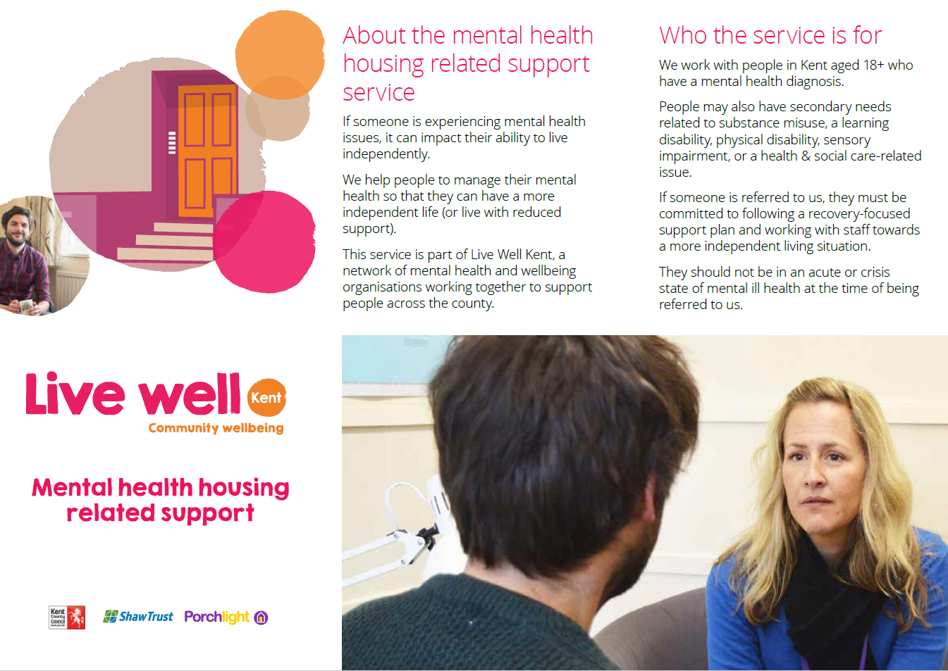

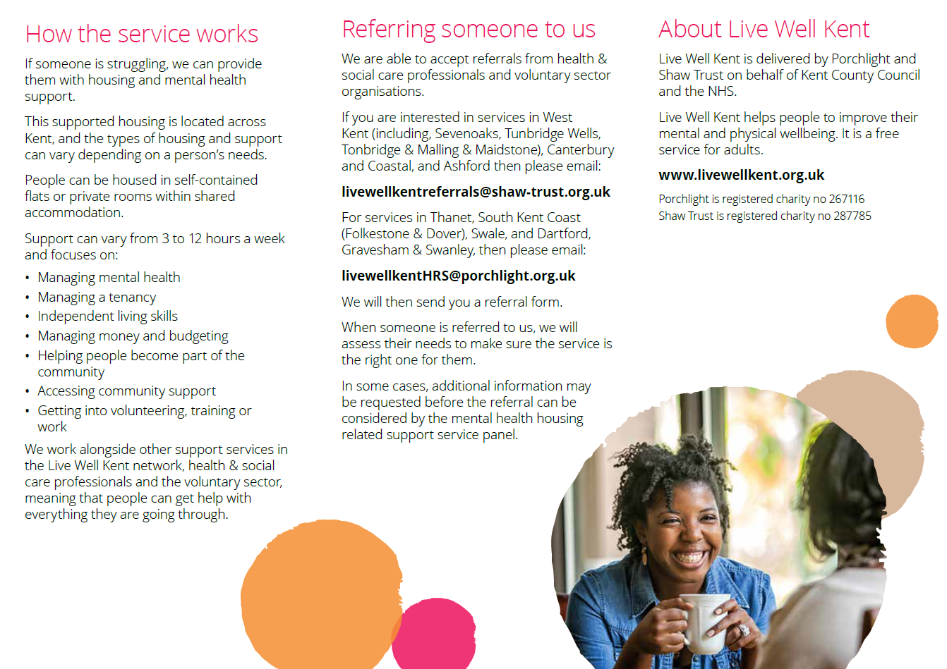

Please click the icon to read the above leaflet as a PDF:

Appendix 2 – location of HRS schemes
Please carefully read the section of the form on local connection in relation to the location of HRS schemes
Ashford | Sevenoaks
Canterbury | Swale
Dartford | Swanley
Folkestone & Hythe | Thanet
Gravesham | Tonbridge & Malling
Maidstone | Tunbridge Wells

