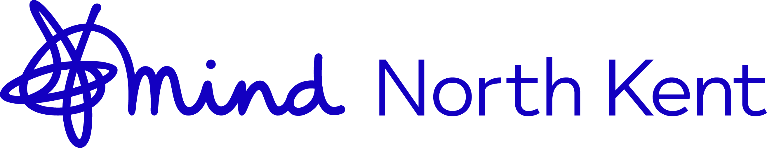

North Kent Mind Modern Slavery Statement 2023

North Kent Mind is a registered charity in Kent, providing mental health support to individuals residing in Dartford, Gravesham, Swanley and Medway.
North Kent Mind believes in the autonomy of individuals to make their own decisions without coercion or control from others, and therefore are fully committed to the Modern Slavery Act 2015. We understand the responsibility it puts on organisations to show the steps taken to prevent modern slavery, and to take action when this is suspected.
In this context, we utilise reputable service and goods suppliers, and are alert to any news reports of substandard employment practices. We include references to the issue of Modern Slavery both within our mandatory training for staff and volunteers, and within our organisational policies, in particular our safeguarding adults policy. Where a client indicates they may have been subject to trafficking or other forms of Modern Slavery, we will work with them appropriately within our existing safeguarding and confidentiality policies.

